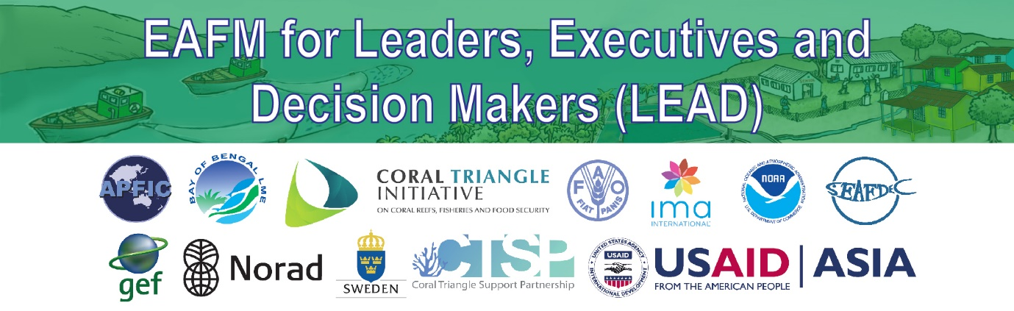
Checklist for organising a high level consultation
The following provides a checklist on how the organise a high level consultation (HLC). This needs to be used at least 1 month before the event.
  - Clarify who is main person responsible for managing the LEAD event;
  - Identify local partners and have a key point of contact and explain that you expect logistics support ahead of event;
  - Find out who the likely audience will be (name, position, role) to understand if they are mid/ senior level;
  - Discuss in your team what audience likely interests/ concerns are and think how you will address and manage these (include hot topic and country);
  - Link up with EAFM resource persons and local partners if you want to brainstorm/ask questions (email/ skype);
  - Develop agenda and outline based on time available and type of audience;
  - Decide who will facilitate what sessions (allocate responsibilities);
  - Discuss with local partner what is required for them to provide;
  - Plan logistics and preparation of materials and send to local partner (see Excel checklist for 1 day consultation);
  - Think about suggestions for follow up actions/ commitments;
  - Ensure you record actions agreed, lessons learnt and future commitments;
  - Circulate report (if expected) or other form of knowledge sharing; and
  - Share feedback and insights on eafmlearn.org and with EAFM resource persons pool.

